HTNO:2403A51349
Batch:14
Assignment 2.3
Task Description#1
Use Google Gemini in Colab to write a function that reads a CSV file and calculates mean, min, max

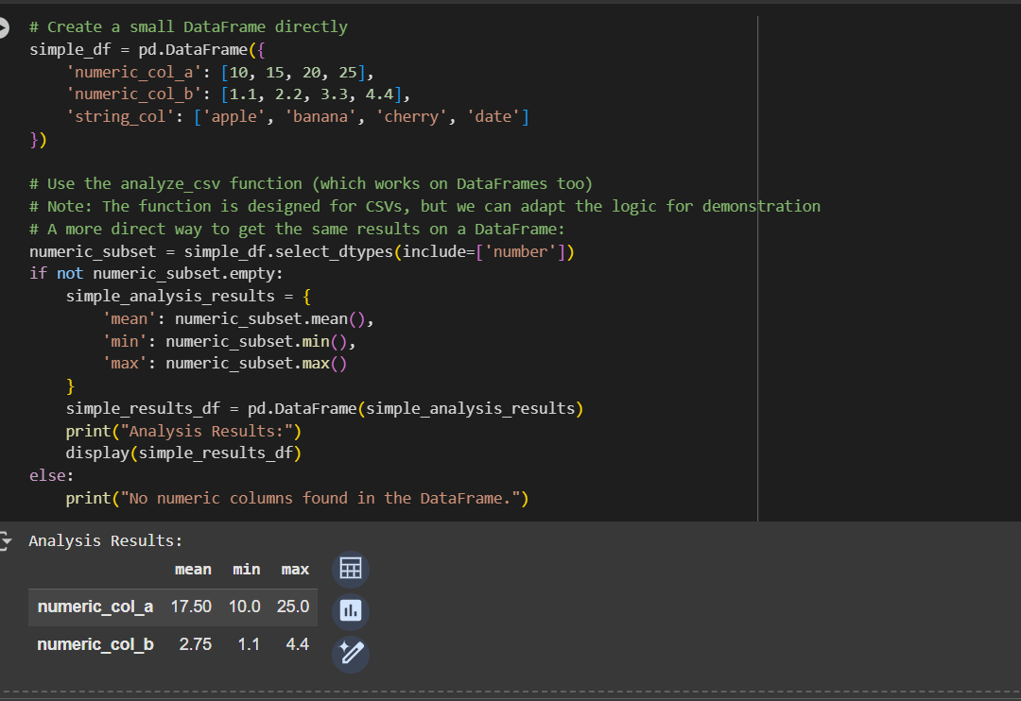

Output:



Task Description#2
Compare Gemini and Copilot outputs for a palindrome check function
GEMINI AI:
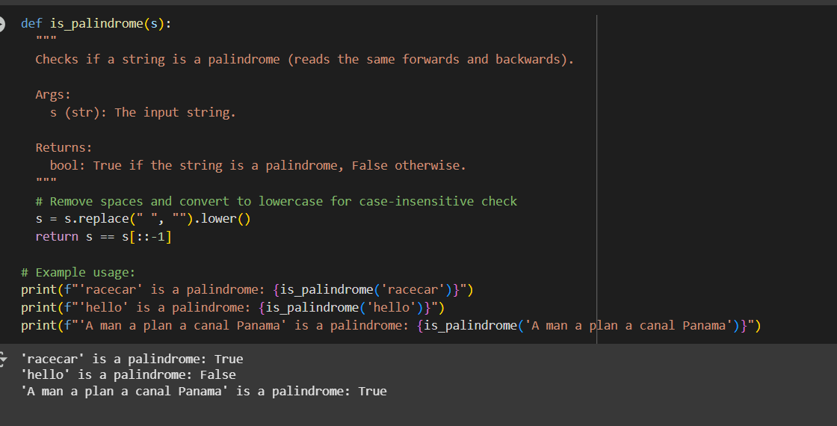
Output:


COPIOLOT:
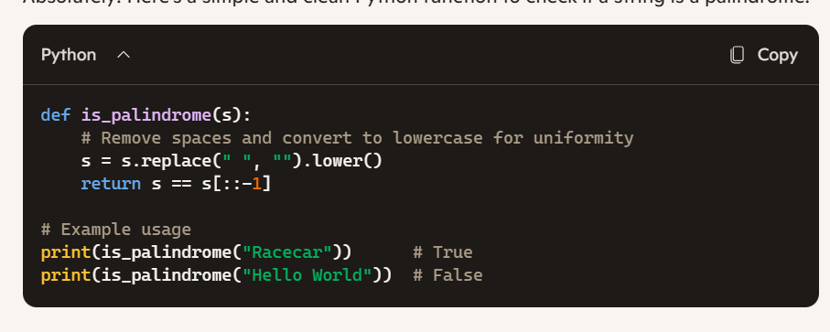

Task Description#3
- Ask Gemini to explain a Python function (to calculate area of various shapes) line by line..

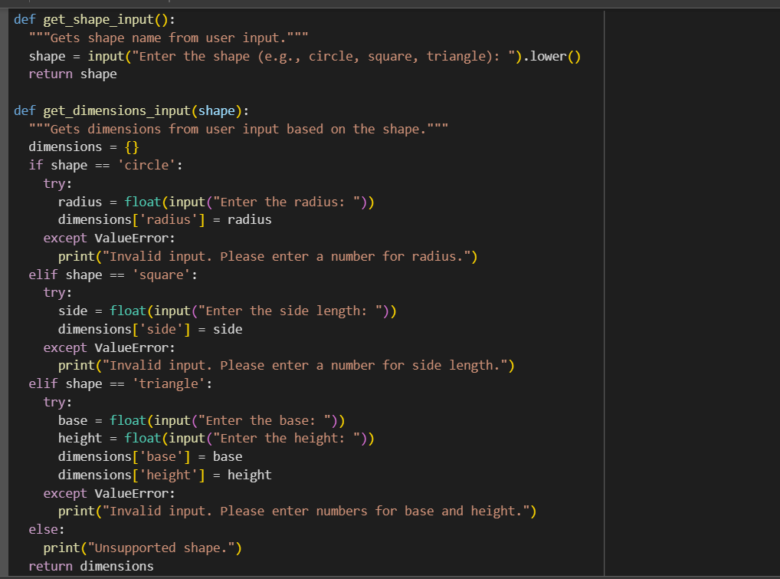

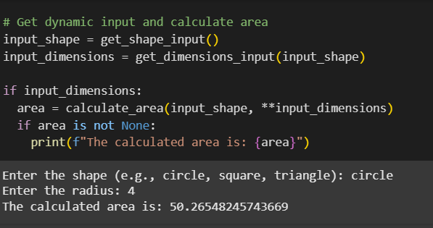

Output:



Task Description#4
- Install and configure Cursor AI. Use it to generate a Python function (e.g., sum of squares).

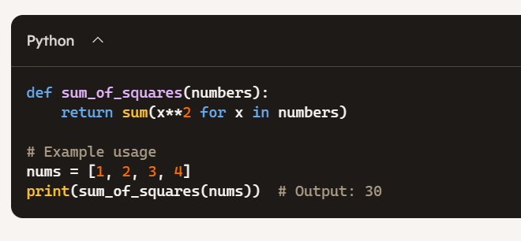

Task Description#5
- Student need to write code to calculate sum of add number and even numbers in the list

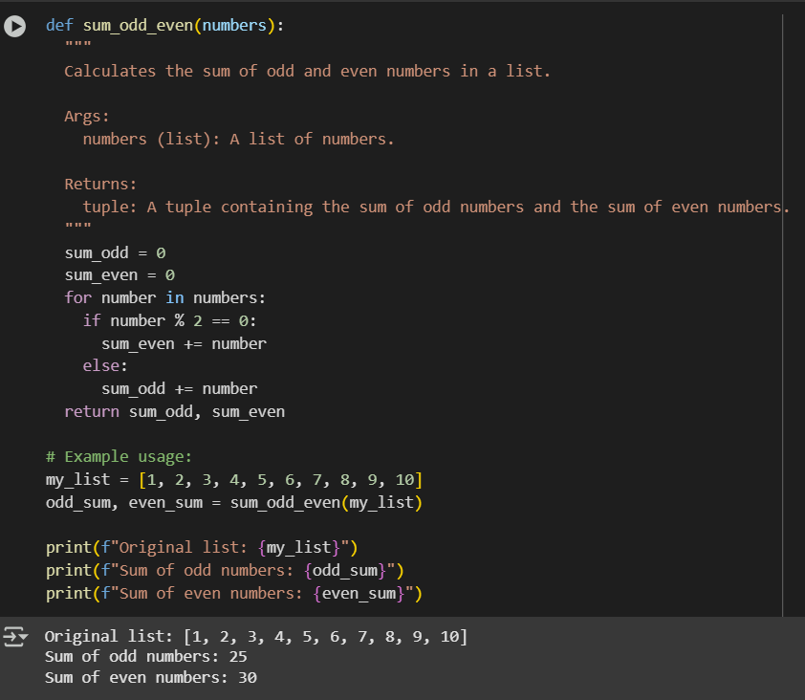

Ouput:



